**ASSIGNMENT ON STRING CLASS**

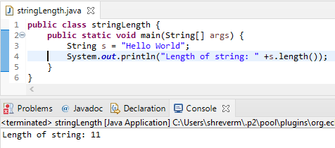

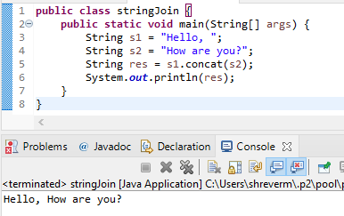

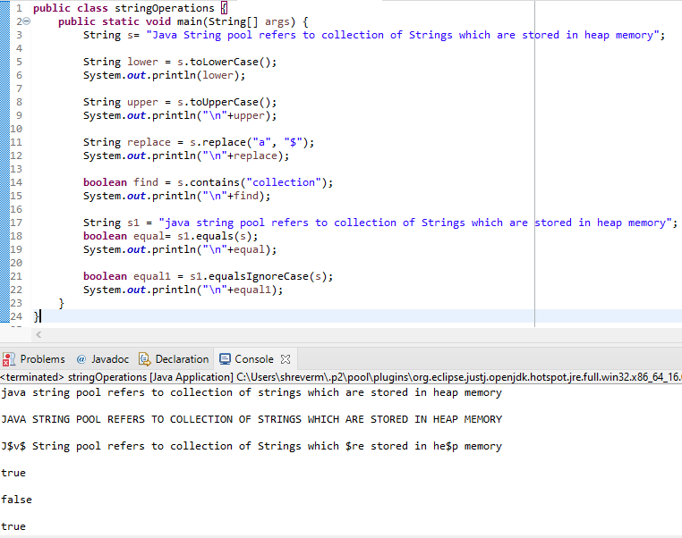

**ASSIGNMENT ON STRINGBUFFER CLASS**

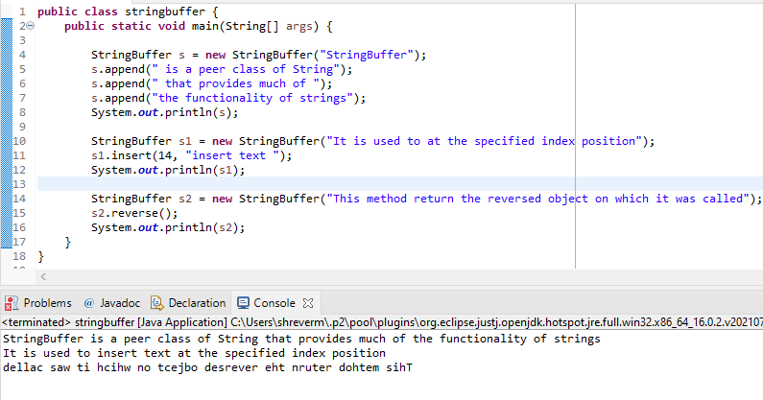

**ASSIGNMENT ON STRINGBUILDER CLASS**

